Constructor in Java->

\***Constructor in java** is a *special type of method* that is used to initialize the object.

*Java constructor is *invoked at the time of object creation*. It constructs the values i.e. provides data for the object that is why it is known as constructor.

Rules for creating java constructor->

There are basically two rules defined for the constructor.

1. Constructor name must be same as its class name
2. Constructor must have no explicit return type

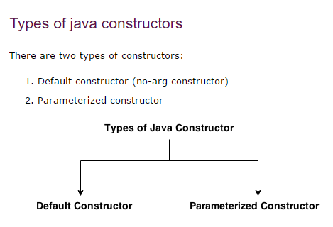

**Java default constructor->**

**A constructor that have no parameter is known as default constructor.**

**Symbol->**

**Class_name()**

**{**

**}**

**Example of default constructor->**

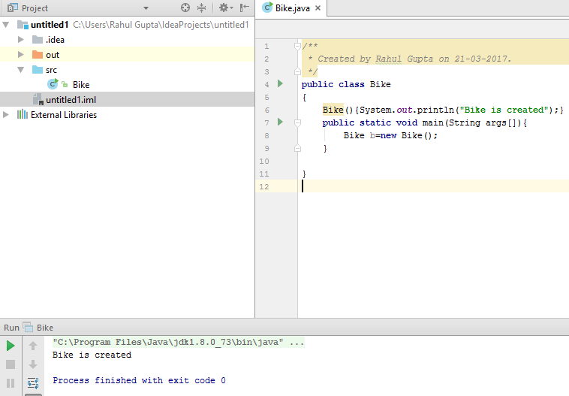

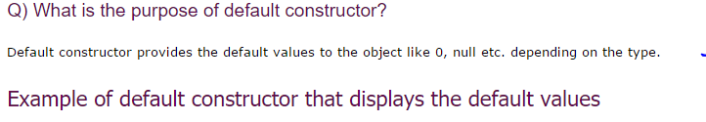

**Why use parameterized constructor?**

|  |
| --- |
| **Parameterized constructor is used to provide different values to the distinct objects.** |

**EXAMPLE->**

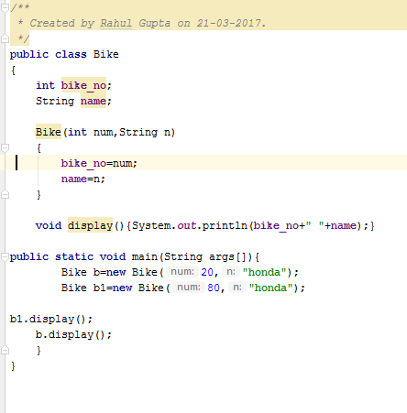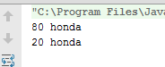

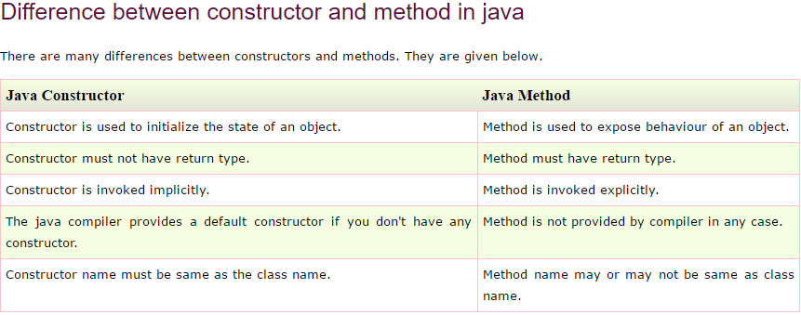

**Copy objects property->**

